**FINAL PROJECT –ECEN 5053**

**Magnetometer, accelerometer and gyro implementation**

**Name: RaghunathReddy**

**Goal**: To understand the implementation and limitation of magnetometer, accelerometer and gyroscope.

**Partial Schematic:**

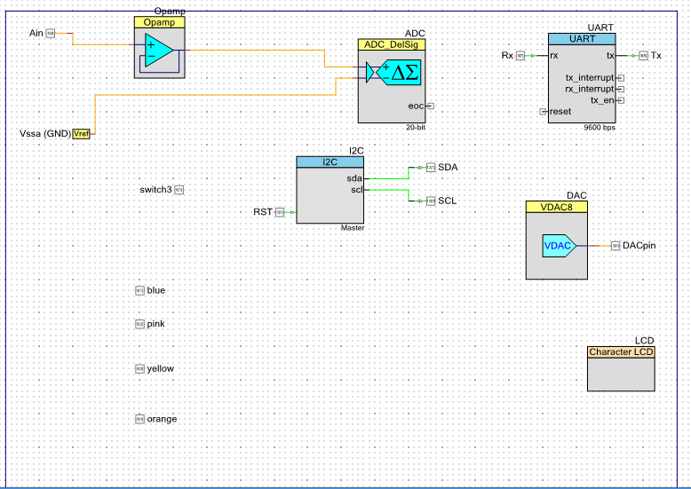

**Pin Assignments:**

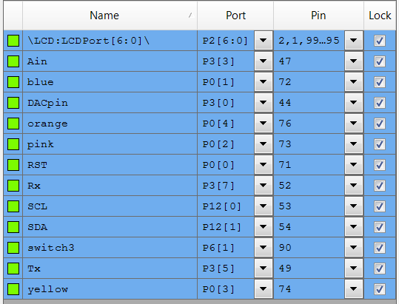

**Test setup during Debug:**

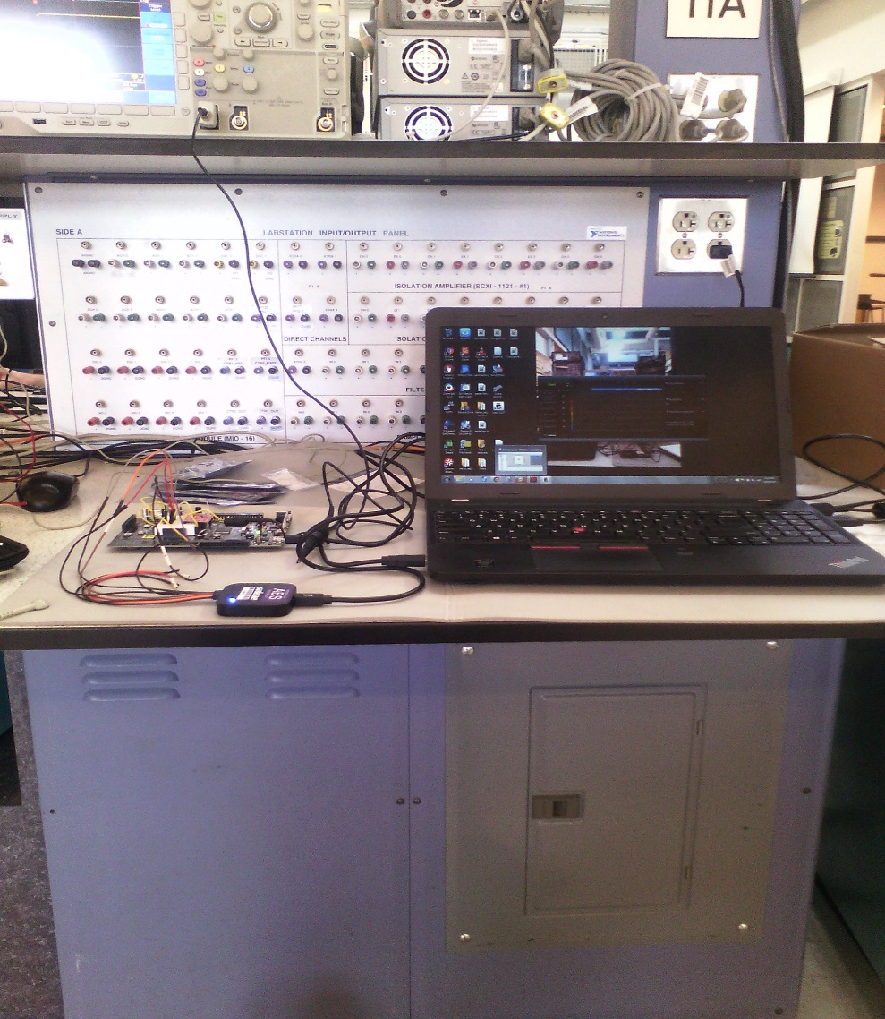

**CYKIT-50 PSoC 5lp**

**Logic analyser**

**Overall test setup**

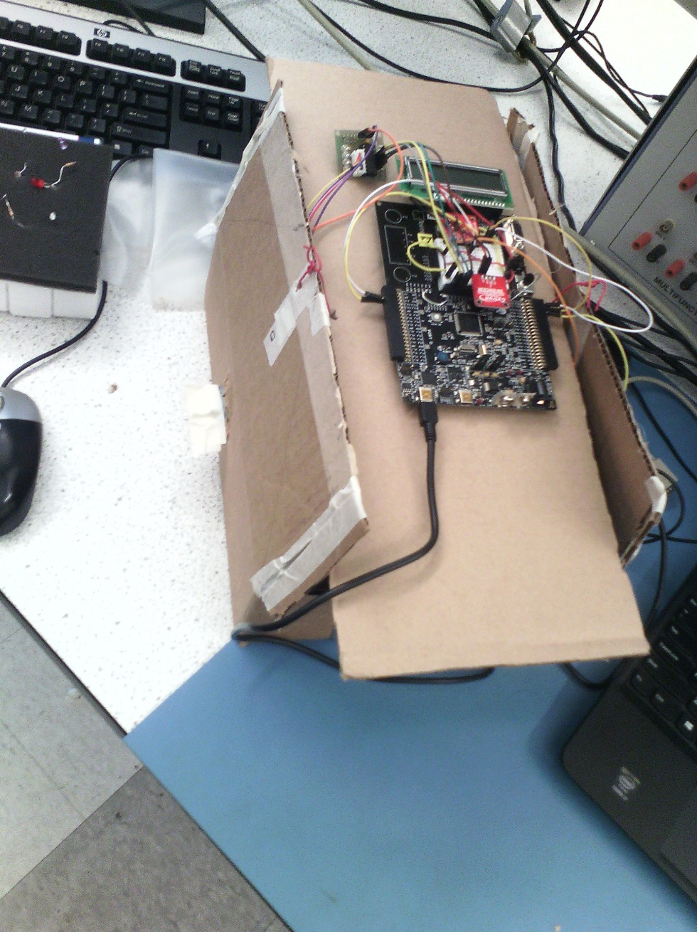

**Single axis Gyro**

**IMU**

**Stepper motor driver**

**Stepper motor**

**IMU-LSM303C**

Break out board is provided by spark fun. Important specs to know about this before we start using the board are:

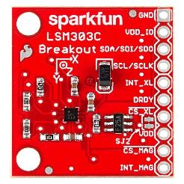

1. Pin outs

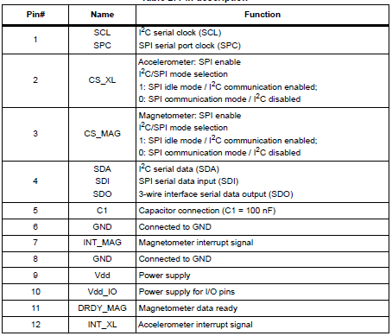

1. We have to choose either SPI/I2C.In this case I have chosen I2C.
2. In I2C, one of the most important thing to know is the slave address and here we have two chips connected to the same I2C bus.

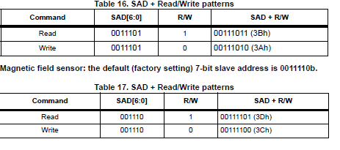

1. Once we get the address we have to check if the slave is receiving it correctly by looking at the acknowledge signal from the slave. Had problems in this stage and had to use logic analyser to debug. A good waveform should look something like the image shown below.

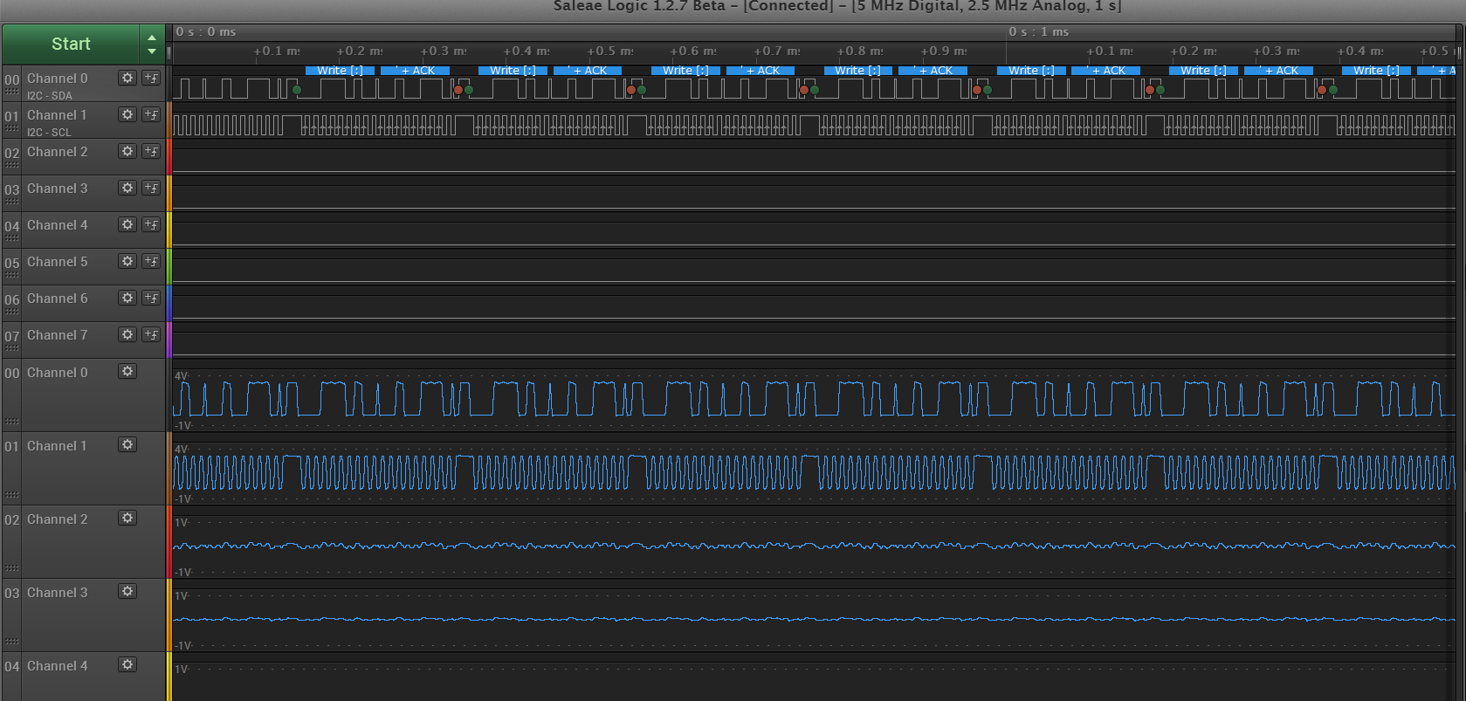

**Slave acknowledge waveform**

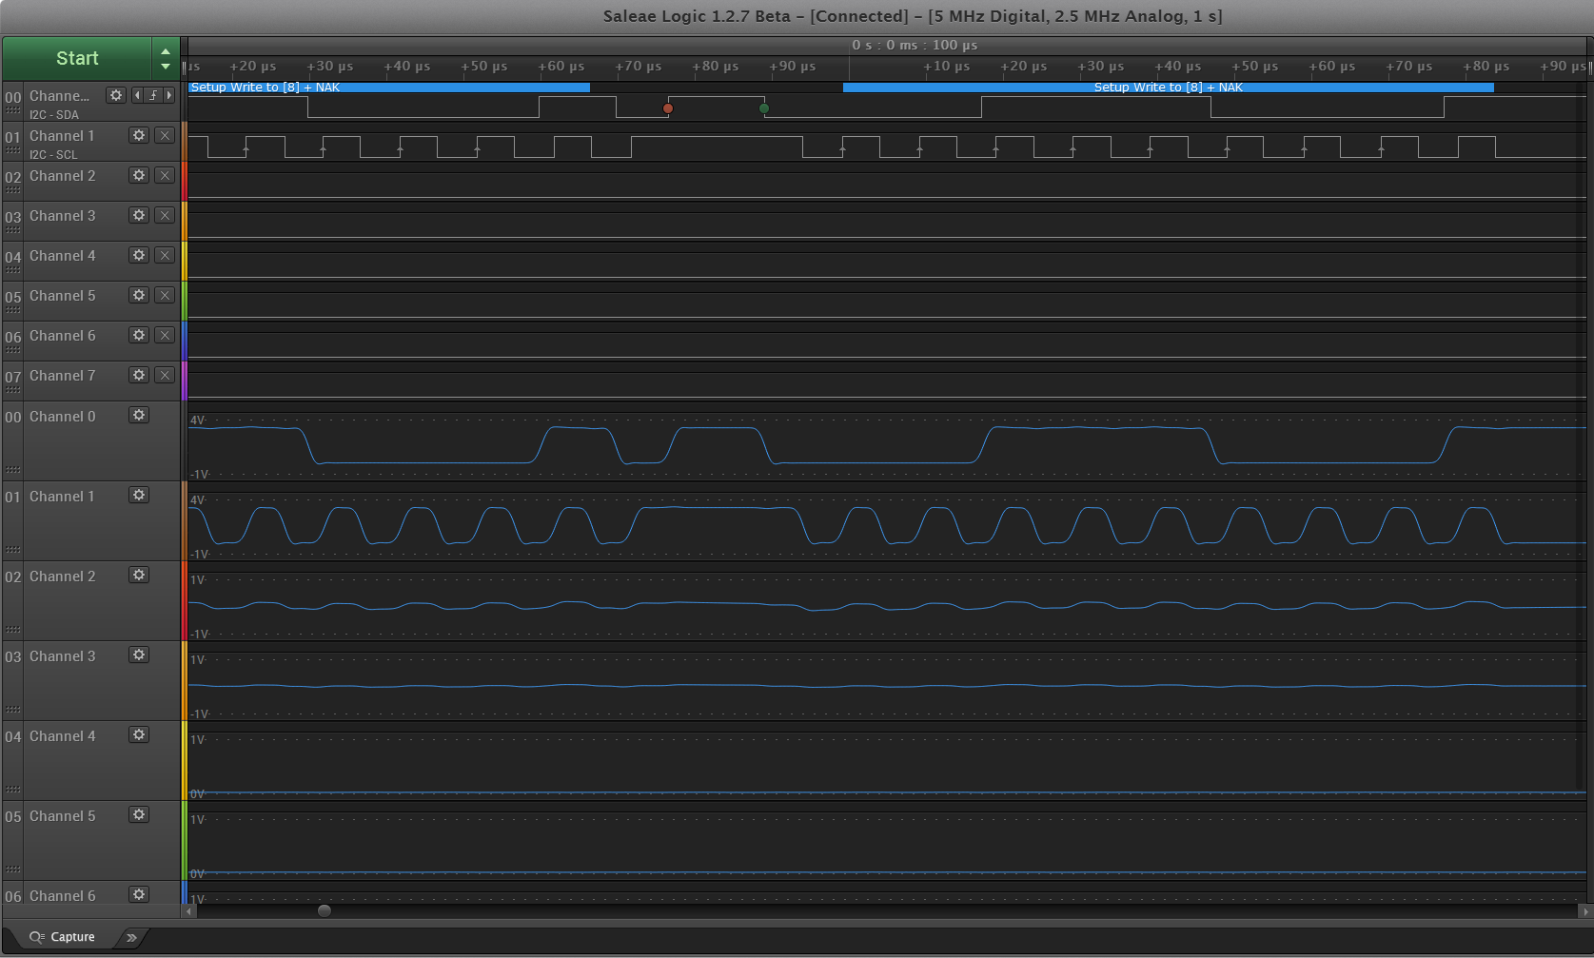

**No acknowledge waveform**

1. Next verify if the read operation is working fine and then start setting the register values to get the desired operation .
2. In this case for the accelerometer firstly enable the outputs and then change the output data rate to 100Hz ,then make sure that range selected is +/- 2g and also change block update should be done I.e. only if the entire 16 bits are received the slave must transmit otherwise till the transaction is complete
3. Once all the parameters are set we can go ahead and read the accelerations due to X,Y, Z.
4. Similarly set the parameters of the magnetometer, for more information can refer to the code for more details.

**Issues faced:**

Slave acknowledge problem:

**Solution:**

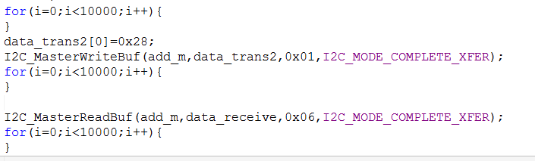

For loops used in the above picture solved the problem. A delay was required for proper transaction of data.

**2.Single axis gyroscope**

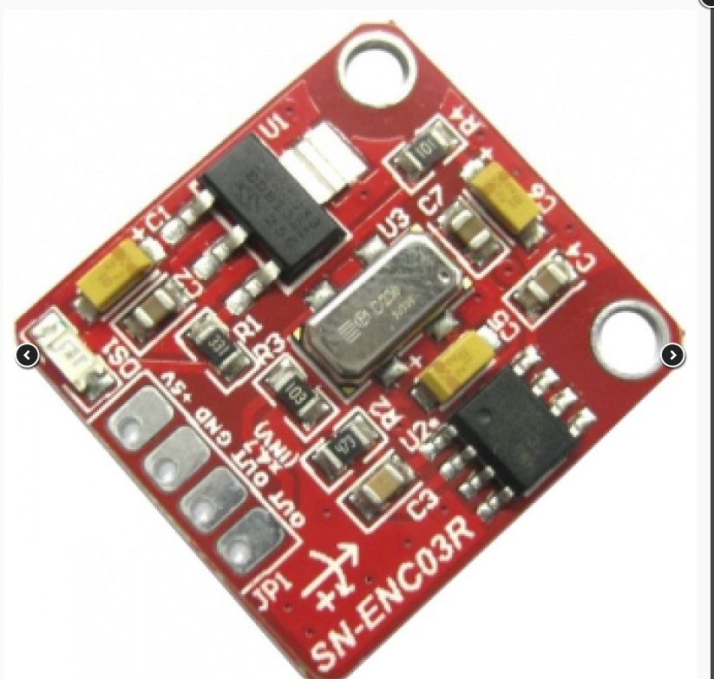

Though I did not have to set an register this sensor took more time to interface has it required more time for signal processing and software to get the right reading.

Important specs

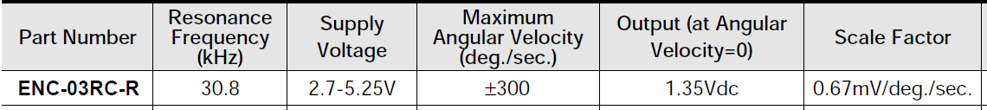

Though it says the output at angular velocity zero is 1.35 but when measured using 10pf scope it was 1.371 which was huge difference for that kind of scale factor. I have made a digital offset in the software instead of using the ADC offset parameter

**Problems faced:**

Even small jerks have huge impact on the output

**Partial solution**

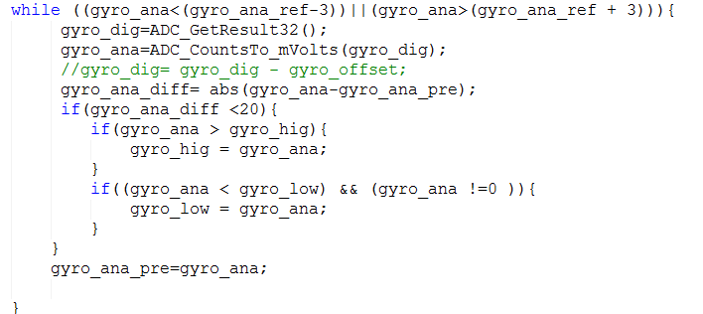

Used a software to filter out the abnormal values.

**Main program:**

There are totally 6 cases

1. Accelerometer : This case the position of the PSoC board is replicated using a stepper motor

2. Magentometer:Used to detect the north on the LCD

3. Gyroscope:Angle of rotation of the setup

4. Matlab-accelerometer:Live data of accelerometer on matlab

5. Matlab-magentometer:Live data of magnetometer on matlab

6. Oscilloscope-gyroscope:Live data of gyroscope on oscilloscope.